Scoping a foundation skills professional standards framework – Consultation Kit
August 2013

This kit should be filled out after participants have read the Scoping a foundation skills professional standards framework consultation paper.

Group Feedback Form
Workshop session date:
Organisation:
Number of participants:
Location:
Facilitator:
Contact details:

Please select the most accurate description of the way in which this feedback represents the views of your workshop participants.
This feedback represents:
the consensus view of participating individuals
the majority view of the workshop participants
a compilation of the range of views expressed by workshop participants
other:…………………………………………………………………………………
Diagram 1: Possible extent of the foundation skills workforce
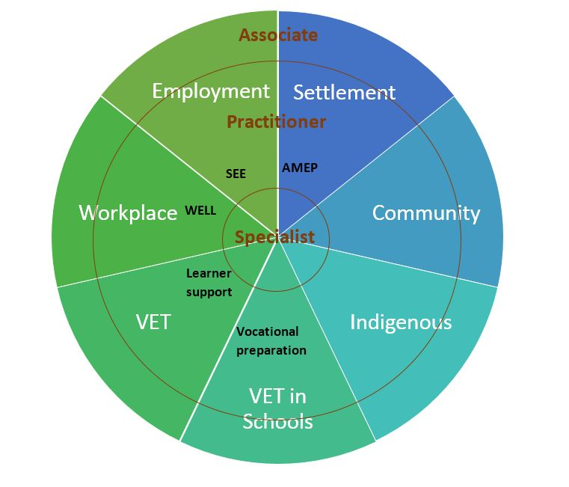
Diagram 1 is a rough sketch of the possible extent of the foundation skills workforce. It is created as a starting point for talking about the diverse environments for foundation skills delivery in Discussion Point 1.

Responses to workshop discussion questions:
Discussion questions | Summary/key points
Discussion point 1: scoping the foundation skills field
Where are the boundaries of the foundation skills field?
Does the field include only occupations that are solely focussed on foundation skills development, or should it include the notion of ‘associated’ job roles that have some responsibility for, or interest in, foundation skills development?
Are there domains, programs or occupations that are missing from diagram 1 (above) – or some that should be excluded?
Is there a need to define and agree upon what is meant by a foundation skills practitioner?

Discussion questions | Summary/key points
Discussion point 2: considering the purpose of a professional standards framework
Should a professional standards framework focus only on foundation skills education specialists or should it also include related occupations where a level of knowledge and skills in foundation skills is an addition to the required core skills and capabilities?
How might the establishment of a professional standards framework strengthen the identity of the foundation skills field and support foundation skills practitioners in their professional practice?
How can the diversity of the foundation skills field be accommodated in a professional standards framework?

Discussion questions | Summary/key points
Discussion point 2: considering the purpose of a professional standards framework (cont…)
What components of a professional standards framework will be critical for ensuring that it is useful and sustainable?
What management mechanisms would need to be put in place to implement and maintain a professional standards framework for the foundation skills field?
What role could existing membership organisations play in the implementation and maintenance of a professional standards framework?

Discussion questions | Summary/key points
Discussion point 3: identifying knowledge and skills for the foundation skills field
Could a matrix or framework of knowledge and skills be developed to describe the range of capabilities needed in the foundation skills field?
Are some areas of knowledge and skills essential for everyone in the field?
Are there identifiable specialisations that could usefully be described in a matrix or framework?
Could any or all of these skills be encapsulated within an existing framework such as the VET Capability Framework? (see Appendix C of the consultation paper)

Discussion questions | Summary/key points
Discussion point 4: using qualifications to describe professional requirements

How do historic and currently available qualifications in LLN relate to the needs of foundation skills specialists?
Do any qualifications fully capture the knowledge and skills required by foundation skills specialists?
Are there any critical skills and capabilities required by the foundation skills workforce that are not covered by any existing formal qualifications?

Discussion questions | Summary/key points
Discussion point 5: defining on the job requirements

Could levels be used to describe developmental stages of foundation skills expertise and experience?
How much on-the-job experience is needed by foundation skills practitioners working in various roles or contexts?
Are there, or should there be, established mechanisms for gaining the necessary on-the-job experience?
Should formal or consistent methods for documenting on-the-job experience be developed?

Discussion questions | Summary/key points
Discussion point 6: creating a system for continuing professional development
Could a system for continuing professional development (CPD) be created that will meet the needs of the foundation skills field?
How can a highly casualised workforce be accommodated in a CPD system?
Who would take responsibility for managing a CPD system?
Should there be one system, or many, to accommodate the diversity of the field?

Discussion questions | Summary/key points
Discussion point 7: establishing requirements for specialist areas
Can areas of specialisation be clearly identified within the foundation skills field?
What is the best way to describe the unique knowledge and skills requirements of specialist areas?
Does there need to be a distinction between specialists who operate across delivery contexts (e.g. numeracy specialists, NESB specialists) and those who specialise in a particular delivery context (e.g. WELL practitioners)?

Discussion questions | Summary/key points
Discussion point 8: determining the need for a code of practice
Are there any ethical operating principles for the foundation skills field that are not already established in the broader education and training system?
What does this mean for practitioners operating outside of accredited VET delivery?
Additional comments/issues?

